**REPORT ON THE GOVERNOR MWALIMU KAHIGA VOLLEYBALL CHAMPIONSHIPS HELD ON 31ST OCTOBER TO 3RD NOVEMBER 2024 AT KAMUKUNJI GROUNDS**

The Department of Gender, Youth, Sports and Social Services in conjunction with the Kenya Volleyball Federation jointly hosted the Mwalimu Kahiga Championship cum the 1st Leg KVF National (Women and Men’s) League which was a four-day event held at Kamukunji Grounds from 31st October to 3rd November 2024. As part of the department’s core mandate, the tournament provided a platform for the promotion of volleyball through identification of talented players especially from our local teams as well identifying areas they need nurturing in to continue excelling in the sport and provision of sporting equipment such as volleyball kits and nets for our local teams. There was a large turnout among the youth showing the growing interest in volleyball within the County and continuous efforts towards promoting and bringing back the glory of volleyball in Nyeri.

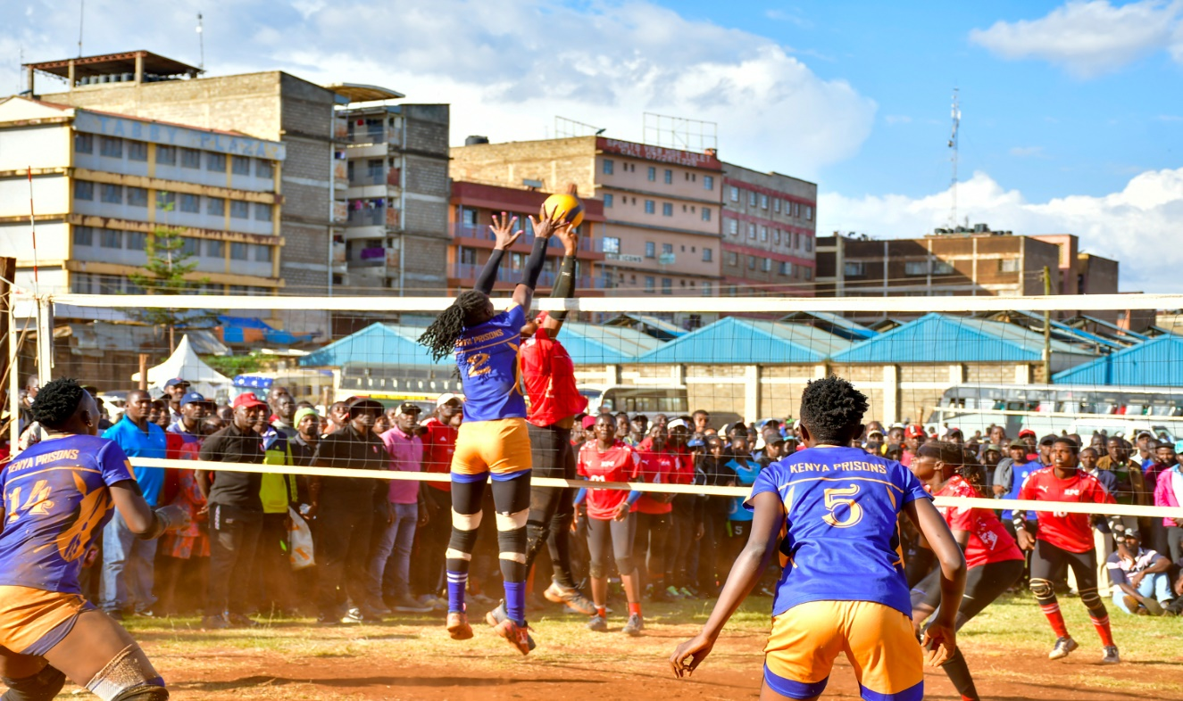

The Championships were not just aimed at showcasing the passion, skills and talents of our local Nyeri teams but also invited teams from other parts of the country which play in the National League. This resulted in a total of 42 teams participating in the event. The two categories that were participating included the Senior Men/Women and Self-Sponsored Men/Women. The teams in the different categories were as follows:

**SENIOR MEN**

1. KPA – Kenya Ports Authority
2. Trailblazers
3. Kenya Army
4. KDF
5. Equity Bank
6. GSU
7. APK – Administration Police Kenya
8. Prisons Kenya
9. Prisons Rift Valley
10. KAPU – Kenya Airports Police Unit
11. RDU – Rapid Development Unit
12. Mounty Kenya Base Yetu
13. Kahawa Wendani

**SENIOR WOMEN**

1. Prisons Kenya
2. DCI
3. KDF
4. KCB
5. KPC
6. Post Bank
7. Kenya Army
8. Vihiga Volleyball
9. Maranatha
10. Young Spikers

**SELF-SPONSORED MEN**

1. Platinum
2. Kakamega Kings
3. Upper Hill
4. Kiganjo Loistan
5. Huruma
6. Hazina
7. Green Farmers
8. Chema Steel
9. Ruring’u
10. Afraha
11. Tetu Junior
12. Karatina University

**SELF-SPONSORED WOMEN**

1. Flush Queens
2. Six Spikers
3. Deaf Volleyball Club
4. Green Farmers
5. Karatina University
6. Panthers

In the self-sponsored category we had our very own seven (7) local teams participating in the tournament which included:

1. Kiganjo Loistan Men

2. Green Farmers Men

3. Tetu Junior Men

4. Ruring'u Men

5. Karatina University Men

6. Green Farmers Women

7. Karatina University Women

**PERFORMANCE OF THE NYERI TEAMS**

**Men’s Teams Performance**

1. **Tetu Junior VC**

* **Match**: Tetu Junior vs Loistan
* **Result**: Tetu Junior (1) - Loistan (3)

1. **Kiganjo Loistan Men**

* **Match**: Kiganjo Loistan vs Upper Hill Volleyball Club
* **Result**: Kiganjo Loistan (0) – Upper Hill (3)
* **Scores**: 23-25, 22-25, 23-25
* They lost their match in straight sets.

1. **Green Farmers Men**

* **Match**: Green Farmers VC vs Hazina
* **Result**: Green Farmers (0) - Hazina (3)
* **Scores**: 16-25, 23-25, 17-25
* Green Farmers Men suffered a 3-0 defeat managing to put up more resistance in the second set but ultimately failing to secure any set.

1. **Karatina University Men**

* **Match**: Kakamega Kings vs Karatina University
* **Result**: Karatina University (1) - Kakamega Kings (3)
* **Scores**: 22-25, 27-25, 18-25, 25-27
* Karatina University Men won one set but lost the match 3-1. The team showed resilience particularly in the second set which they won.

1. **Ruring'u Men**

* Ruring'u played their first match against Afraha and their second match against Chema VC.
* **Results**: Ruring'u (0) - Afraha (3)

Ruring'u (0) - Chema (3)

**Women’s Teams Performance**

1. **Karatina University Women**

* **Match 1**: Karatina University vs Deaf Volleyball Club
* **Result**: Karatina University (3) - Deaf VC (0)
* **Scores**: 25-8, 25-11, 25-11
* **Match 2**: Karatina University vs Flush Queens
* **Result**: Karatina University (0) - Flush Queens (3)
* **Scores**: 13-25, 13-25, 17-25
* Karatina University Women had a strong victory against Deaf VC winning all sets convincingly, however, they struggled against Flush Queens losing in all sets.

2. **Green Farmers Women**

* **Match 1**: Green Farmers vs Panthers VC
* **Result**: Green Farmers (0) - Panthers VC (3)
* **Scores**: 8-25, 15-25, 21-25
* **Match 2**: Deaf VC vs Green Farmers
* **Result**: Green Farmers (3) - Deaf VC (0)
* **Scores**: 25-10, 25-21, 25-13
* Green Farmers Women had mixed results. They were defeated 3-0 by Panthers VC showing improvement with each set. However, they secured a dominant 3-0 victory over Deaf VC showcasing their capability to bounce back.

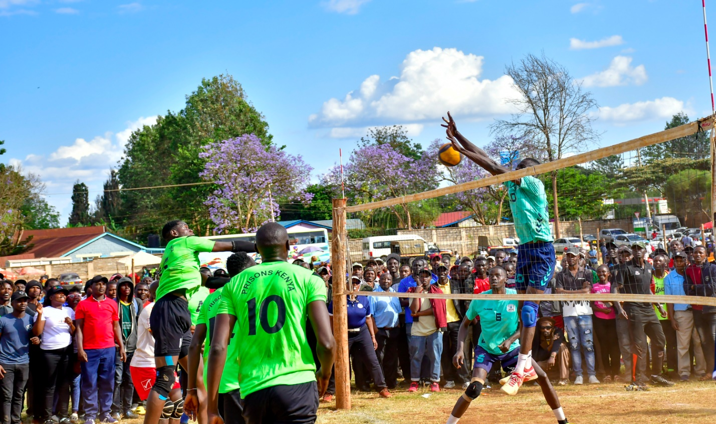

The winning teams in the two categories were awarded cash prizes and trophies as follows:

**Senior Men’s Teams**

**Position**

1. KDF & GSU – Kshs. 150,000

* The two teams tied after time out thus sharing the cash prize equitably

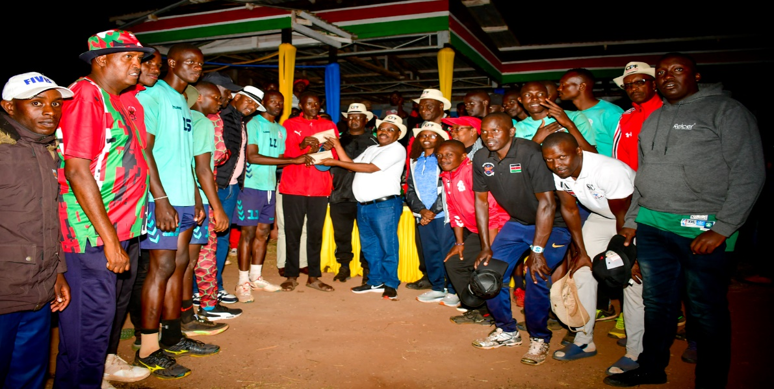

**Senior Women’s Teams**

**Position**

1. Kenya Prisons – Kshs. 100,000
2. Kenya Pipeline – Kshs. 50,000

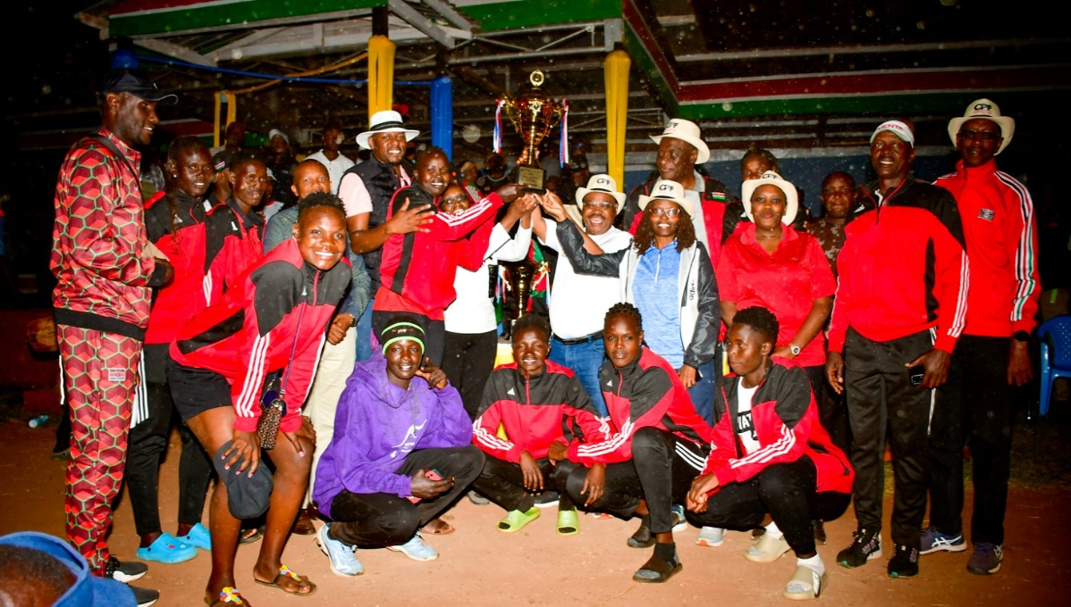

**Self-sponsored Men’s Teams**

**Position**

1. Upper Hill VC – Kshs. 30,000
2. Hazina VC – Kshs. 20,000

**Self-sponsored Women’s Teams**

**Position**

1. Panthers – Kshs. 30,000
2. Flush Queens – Kshs. 20,000

The Championships were graced by H.E the Deputy Governor, CECM & Chief Officer of the host Department, Nominated MCA Gender, Kenya Volleyball Federation (KVF) National office including the President, Deputy President, National Secretary General and National Sports Organizing Secretary and Nyeri branch officials among other dignitaries.

The tournament was indeed successful and boasted the inclusion of female deaf players from Laikipia County which emphasized and promoted the principle of inclusion in sports by ensuring that the activity was accessible to Persons with Disabilities (PWDs).

Report compiled by;

Catherine Nderitu Rozina Nderi

**Sports Officer Sports Officer**